**İSTANBUL ÜNİVERSİTESİ**

**BİLGİSAYAR MÜHENDİSLİĞİ**

**Bilgisayar Organizasyonu ve**

**Tasarımı Laboratuvarı**

**Uygulama 3 :**

T Flipflop and Asynchronous Counter Using T flipflop

1.T Flipflop

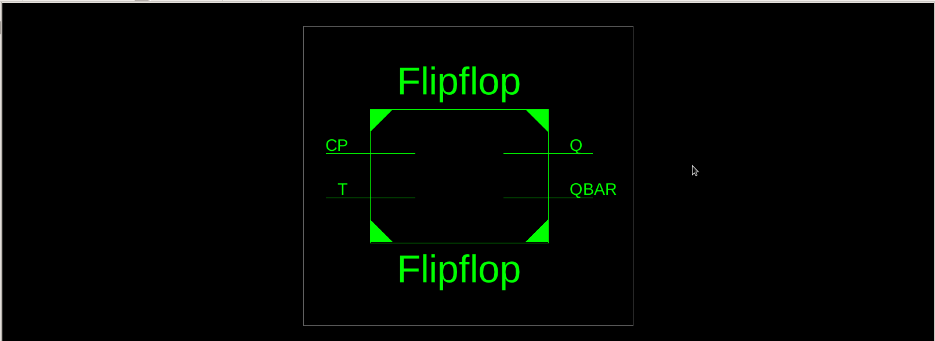

1.1-Detaylı şema

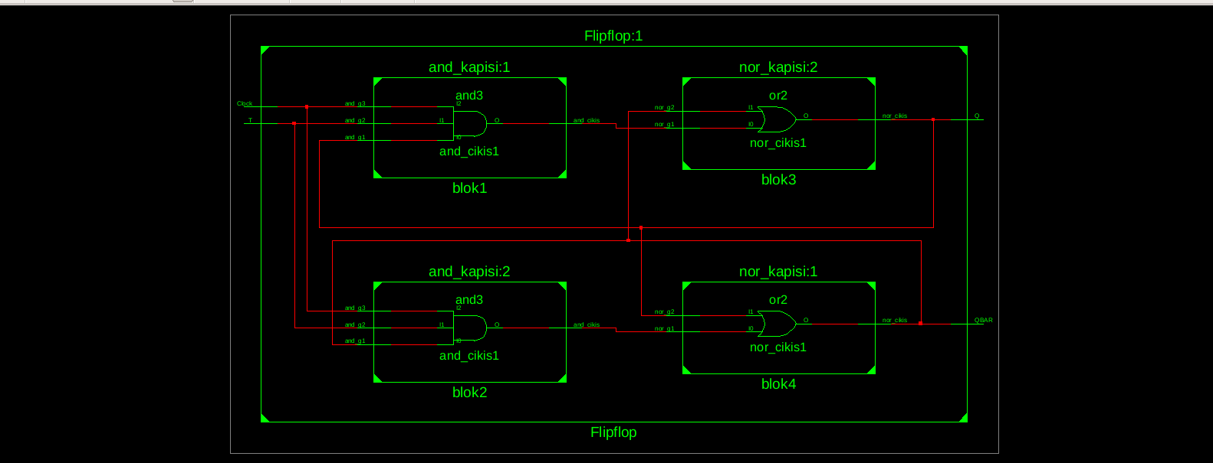

Kod

library IEEE;

use IEEE.STD_LOGIC_1164.ALL;

entity nor_kapisi is

port( nor_g1: in STD_LOGIC;

nor_g2: in STD_LOGIC;

nor_cikis: out STD_LOGIC);

end nor_kapisi;

architecture Behavioral of nor_kapisi is

begin

process(nor_g1,nor_g2)

begin

nor_cikis <= nor_g1 or nor_g2;

end process;

end Behavioral;

----------------------------------------------------------------------------------

library IEEE;

use IEEE.STD_LOGIC_1164.ALL;

entity and_kapisi is

port( and_g1: in STD_LOGIC;

and_g2: in STD_LOGIC;

and_g3: in STD_LOGIC;

and_cikis: out STD_LOGIC);

end and_kapisi;

architecture Behavioral of and_kapisi is

begin

process(and_g1,and_g2,and_g3)

begin

and_cikis <= and_g1 and and_g2 and and_g3;

end process;

end Behavioral;

----------------------------------------------------------------------------------

library IEEE;

use IEEE.STD_LOGIC_1164.ALL;

entity Flipflop is

port( T: in STD_LOGIC;

CP : in STD_LOGIC;

Q : inout STD_LOGIC;

QBAR : inout STD_LOGIC);

end Flipflop;

architecture Behavioral of Flipflop is

component nor_kapisi is

port( nor_g1: in STD_LOGIC;

nor_g2: in STD_LOGIC;

nor_cikis: out STD_LOGIC);

end component;

component and_kapisi is

port( and_g1: in STD_LOGIC;

and_g2: in STD_LOGIC;

and_g3: in STD_LOGIC;

and_cikis: out STD_LOGIC);

end component;

signal arakablo1:STD_LOGIC;

signal arakablo2:STD_LOGIC;

begin

blok1: and_kapisi port map(and_cikis=>arakablo1,and_g1=>Q, and_g2=>T, and_g3=>CP);

blok2: and_kapisi port map(and_cikis=>arakablo2,and_g1=>QBAR,and_g2=>T,and_g3=>CP);

blok3: nor_kapisi port map(nor_cikis=>Q,nor_g1=>arakablo1,nor_g2=>QBAR);

blok4: nor_kapisi port map(nor_cikis=>QBAR,nor_g1=>arakablo2,nor_g2=>Q);

end Behavioral;

2. Asynchronous Counter

RTL Şematik

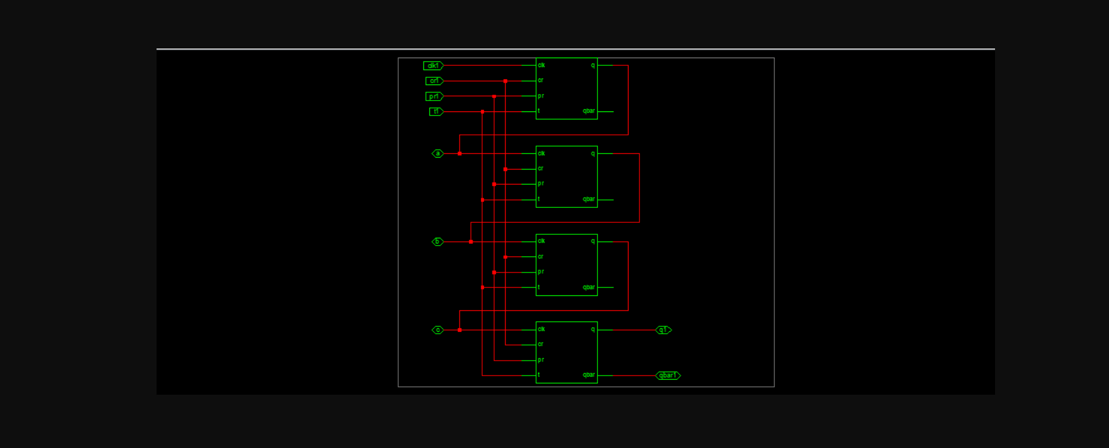

Simülasyon

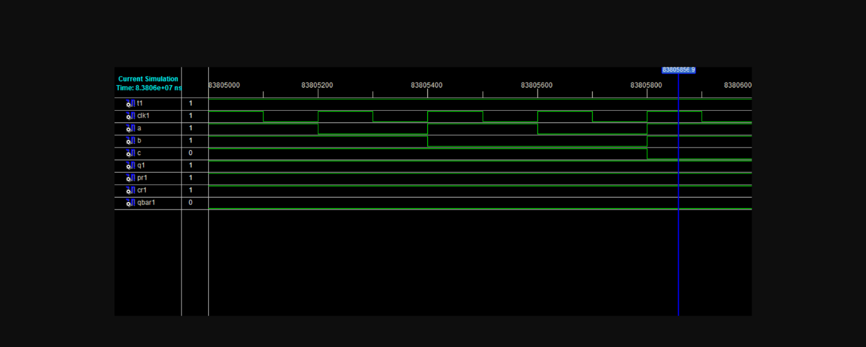

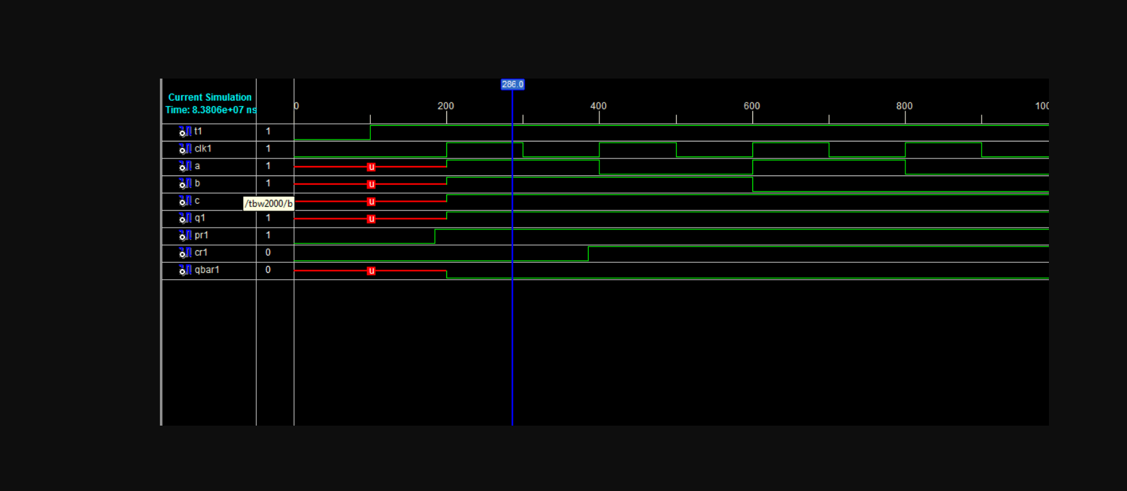

KOD

library IEEE;

use IEEE.STD_LOGIC_1164.ALL;

use IEEE.STD_LOGIC_ARITH.ALL;

use IEEE.STD_LOGIC_UNSIGNED.ALL;

entity async is

Port ( t1 : in STD_LOGIC;

clk1 : in STD_LOGIC;

a : inout STD_LOGIC;

b : inout STD_LOGIC;

c : inout STD_LOGIC ;

q1 : inout STD_LOGIC;

pr1: in STD_LOGIC;

cr1: in STD_LOGIC;

qbar1 : inout STD_LOGIC);

end async;

architecture Behavioral of async is

component t_ff4 is

Port ( t : in STD_LOGIC;

clk : in STD_LOGIC;

pr: in STD_LOGIC;

cr: in STD_LOGIC;

q : inout STD_LOGIC;

qbar : inout STD_LOGIC);

end component;

signal abar,bbar,cbar:STD_LOGIC;

begin

tff1: t_ff4 port map (t1,clk1,pr1,cr1,a,abar);

tff2: t_ff4 port map (t1,a,pr1,cr1,b,bbar);

tff3: t_ff4 port map (t1,b,pr1,cr1,c,cbar);

tff4: t_ff4 port map (t1,c,pr1,cr1,q1,qbar1);

end Behavioral;